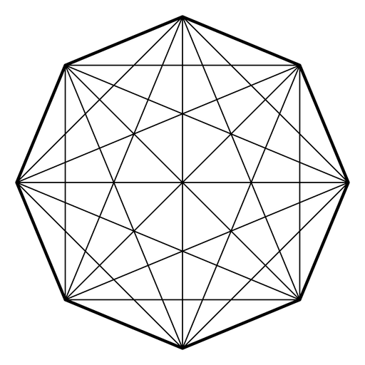
Mystic Math:
Sacred Shapes & Symbols Worksheet!

Course: SuperheroSTEM:
Materials: A pencil & paper (notebook); Symbols Worksheet; Imagination
Created by: Ryan Saelens

MISSION BRIEFING:
Welcome, Initiate.
For centuries, the knowledge of shapes has been more than simple geometry — it has been the language of power, design, and hidden order. Across ancient civilizations, symbols were created not for decoration, but for precision. For purpose. For protection.
These symbols — circles, triangles, and other polygons woven together — form the core of sacred geometry—where magic and math intersect.
You’ve been chosen to enter this forgotten tradition.
Your objective is clear:
- Study the elemental forms: the building blocks of all magical design.
- Decode ancient seals and diagrams, identifying the shapes hidden within.
- Use geometry to create your own symbol — one that carries meaning and intent.
- Complete final tests of recognition, logic, and design to prove mastery.
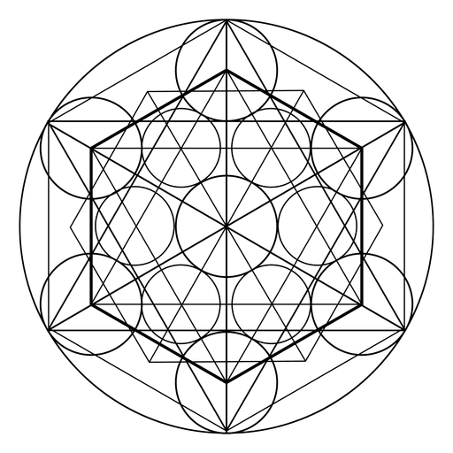
This is no mere math course.
This is a training ground for thinkers, builders, and guardians of forgotten knowledge. Your journey begins now.

SKILLS TO MASTER:
- 🔍 Geometric Inquiry
- 🧠 Symbol Analysis
- 🎨 Creative Design
- 🎓 Mathematical Communication
- 📈 Pattern Recognition

LEARNING GOALS:
- Identify and classify 2D shapes and polygons by sides, angles, and symmetry
- Recognize and analyze shapes within complex, symbolic designs, and Nature
- Construct original symbols using geometric shapes with intention
- Apply shape recognition through visual tasks like color-coding and design
- Use precise mathematical vocabulary to describe and compare shapes
- Understand how geometry connects to symbols, structures in Nature, and ancient knowledge

So, WHAT exactly is Geometry?
Imagine the world as a giant puzzle made of shapes. Geometry is the special language we use to understand those shapes — from the tiniest triangle to the largest circle — and how they fit together.
Broadly speaking, geometry is the study of points, lines, angles and surfaces. Geometry helps us see patterns in Nature, design incredible buildings, create powerful symbols, and even understand how superheroes move through space!
Think of geometry as the magic behind the scenes — the rules and secrets that make everything from spiderwebs to star maps possible.
So, whether you’re drawing a symbol or decoding an ancient seal, geometry is your key to unlocking the hidden order of the universe.
Ready to become a master of shapes and symbols? Let’s dive in!
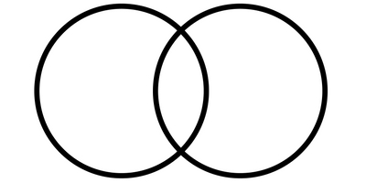
Module 1: The Building Blocks of Magical Symbols!
Familiarize yourself with the fundamental 2D shapes and polygons that form the foundation of all magical symbols.
The most fundamental shapes, otherwise known as primitive shapes, are simply the following:
- Triangle
- Square
- Rectangle
- Circle

What is a POLYGON then?
A polygon is a flat, closed shape made by connecting straight line segments end to end. (QUICK! Is a circle a polygon?)
- Each straight line is called a side.
- The points where the sides meet are called vertices (think of them like corners).
- Polygons can have any number of sides — from triangles with 3 sides, all the way up to shapes with many sides! Here is a list of polygons with sides from 3 to 10:
  - Triangle — 3 sides
  - Quadrilateral — 4 sides (includes squares, rectangles, trapezoids)
  - Pentagon — 5 sides
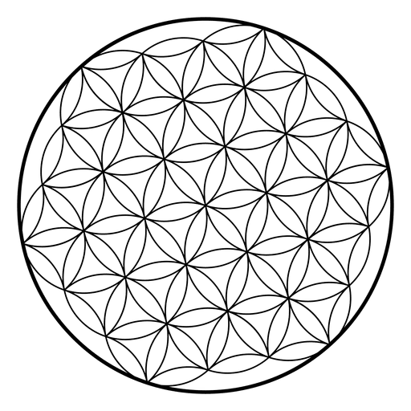
  - Hexagon — 6 sides
  - Heptagon — 7 sides
  - Octagon — 8 sides
  - Nonagon — 9 sides
  - Decagon — 10 sides

On a separate piece of paper, draw each of the shapes listed above. Be sure to label each shape.
What makes a polygon special is that its sides always connect to form one continuous loop, with no gaps or curves. If the lines don’t close together to make a shape, it isn’t a polygon.

Regular vs Irregular Polygons – WHAT’S the DIFFERENCE?
- Regular polygons have all their sides the same length and all their angles the same size.
  - Can you think of an example of a regular polygon?
    - Draw your example in your notes.
- Irregular polygons have sides and angles that are not all the same size.
  - Can you think of an example of an irregular polygon?
    - Draw your example in your notes.

Module 2: Shape Exploration Exercise #1
Now that you’ve met the basic shapes, it’s time to become a Shape Detective! Magical symbols are built from these shapes — your mission is to find them hidden inside.

Activity: Find the Shapes in the Symbols!
Instructions:
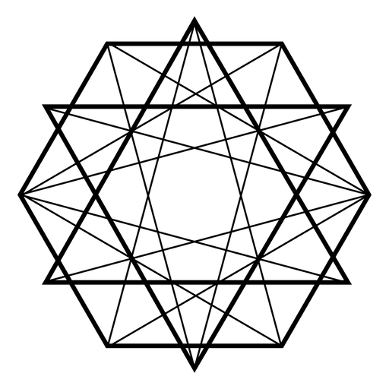
- DOWNLOAD and OPEN the SYMBOLS WORKSHEET found on the LESSON ONE OVERVIEW PAGE
- Look carefully at each magical symbol! There are five.
- Circle or list every shape you can find — triangles, circles, squares, hexagons, and more!
- For each shape, label it regular or irregular.
NOTE: For complex symbols, you DO NOT have to label every shape—as certain symbols have many. Just label a handful—enough to show that you are attempting to understand the assignment.

Module 3: Shape Exploration Exercise #2
Activity: Find the Shapes in Nature!
Instructions:
- Look carefully at objects in Nature such as, trees, fields, flowers, rocks, etc.!
- Make a list of objects along with the shapes and/or symbols (use the symbols from the symbols worksheet) that help create it!
- For each shape, label it regular or irregular.

Guiding Questions For Above Exercises!
- Do you see any triangles?
- Can you find any circles or semicircles?
- Are the shapes all the same size or different?
- Which shapes are regular? Which are irregular?
- Can you spot any polygons with 5 or more sides?
- Which symbol was the most complex?
- Did you find any of the magical symbols in Nature? Please list them.

Module 4: Symbol Creation Challenge!
You’ve explored the building blocks of magical symbols, as well as how these symbols hide in Nature. Now it’s your turn to become a symbol maker! Using circles, triangles, squares, and other polygons, you’ll create a symbol (or two—shoot, make three if you want!) that could hold power and tell a story!

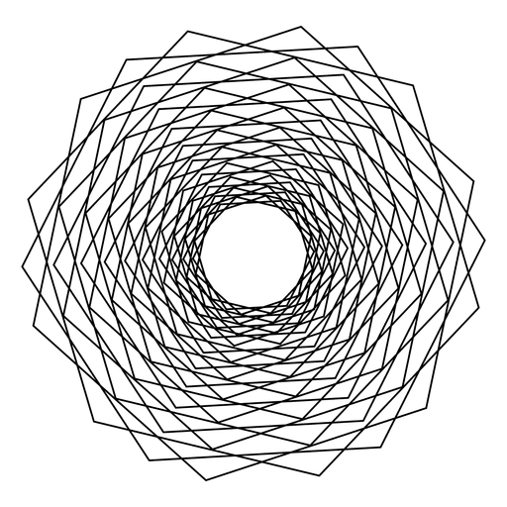
Instructions:
- Choose your shapes: Pick 4-6 shapes from the set to use in your symbol.
- Arrange your shapes: Think about how the shapes fit together. Overlap, rotate, or place them side-by-side to create an interesting design.
- Think about meaning: What might your symbol represent? Power, protection, wisdom? You can give your symbol a name!
- Draw and color: Sketch your symbol and add colors if you want!
- Describe your symbol: Write a short explanation of the shapes you used and what your symbol means.

Mission Checklist:
- 🔺 Shapes and polygons reviewed
- 🧠 Hidden shapes identified within magical symbols – and Nature
- 🌀 Custom symbol(s) designed using geometric forms
- ✏️ Explanation written for your symbol’s design and meaning
- ✅ Final symbol(s) polished and ready to present or share!

Image Credit: I do not own the background images. Though these symbols are sacred symbols that can be found in reality, the ones’ being used for this worksheet are products of Vexels.com.

